**6. Keywords**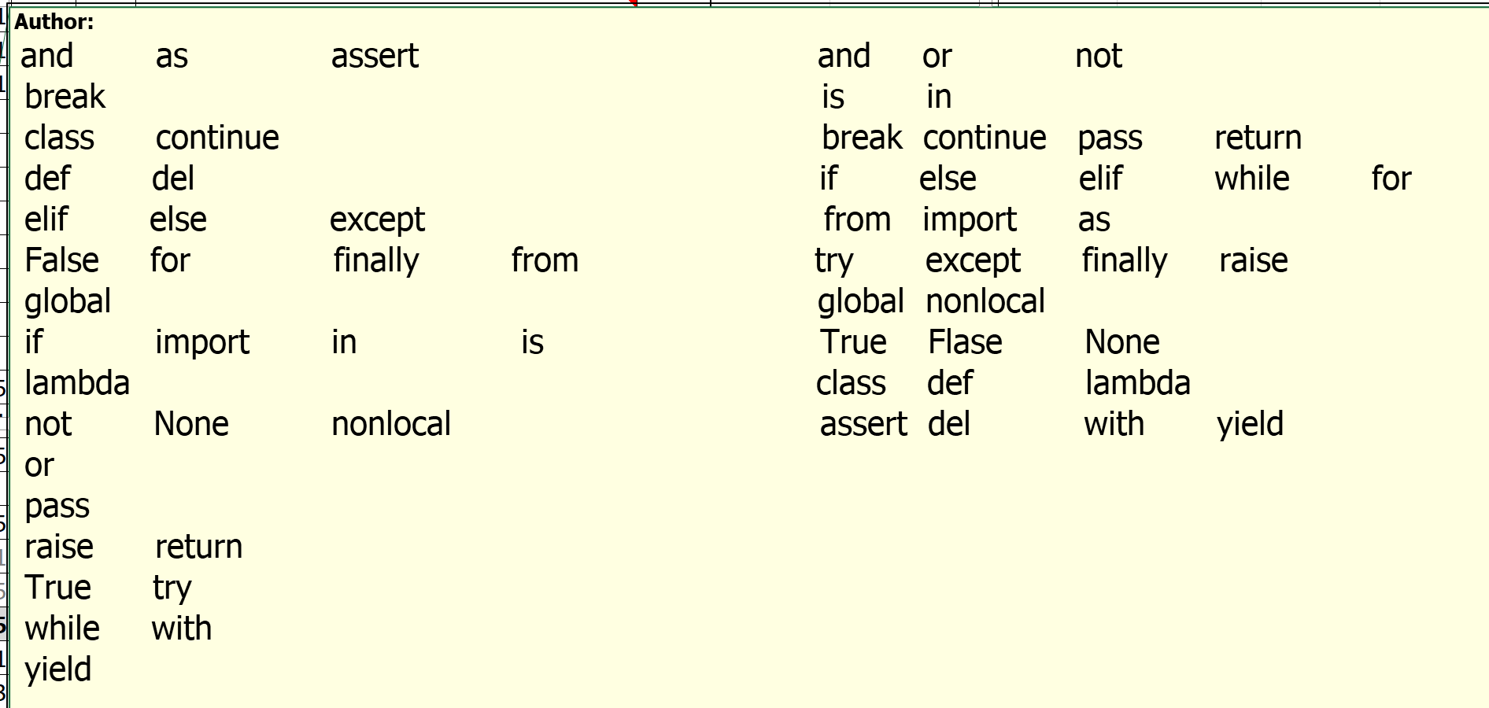

**And or not is in True False**

**X = 20**

**age = 20**

**and = 20**

**And = 20**

**true = 20**

**id name salary address FROM EMPLOYEE**

**ID NAME SALARY ADDRESS from employee**

**Break continue pass return**

**Age = 20**

**age = 35**

**and or not**: Logical operators

**is**: Identity operator

**in**: Membership operator

**break continue pass return** : used in methods to control flow of program

**if else elif while for** : Used for decision making,loops

**True False**: Boolean constants

**from import as** : While importing packages, pyfiles, modules

**try except finally raise** :Used during Exception Handling

**global nonlocal** :To define scope of variable

**class def lambda** :Used in OOPs

**assert del with yield** : Miscellaneous usage